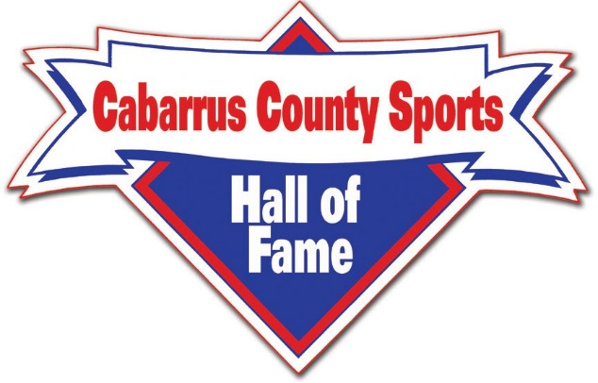

E.Z. SMITH, III – CHAIRMAN BRYAN TYSON - VICE CHAIRMAN HARRY MILLS – SECRETARY JIMMY AUTEN – TREASURER
2025 FUNDRAISING CAMPAIGN
LEVELS OF CONTRIBUTIONS: “LIFETIME” CONTRIBUTORS - $10,000.00 7 - YEAR “LEGACY” SPONSORSHIP - $5000.00 3 - YEAR “CORPORATE” / INDIVIDUAL SPONSORSHIP - $2500.00 1 - YEAR “CORPORATE” / INDIVIDUAL SPONSORSHIP - $1000.00 1 – YEAR “DONOR: - $500.00 “CONTRIBUTOR” - $100.00 “ASSOCIATE” - $50.00
PLEASE MAKE CHECKS PAYABLE TO: Cabarrus County Sports Hall of Fame. MEMO LINE: Write the LEVEL of Contribution you are Making.
Contributor’s Name / Company: ________________________________________ Address: ___________________________________________________________ City:_____________________ State: __________________ Zip Code: _________ Email: _____________________________________________________________ Business Phone: ______________Home Phone: ___________Cell: ____________
CONTRIBUTION AMOUNT: __________ TYPE OF PAYMENT ____________
MAIL THIS FORM and CHECKS TO: FOR OTHER PAY OPTIONS Cabarrus County Sports Hall of Fame Email: cabcosportshof@gmail.com P. O. Box 1374 or Go to our WEBSITE Mt. Pleasant, NC 28124 www.cabarrussportshof.com

