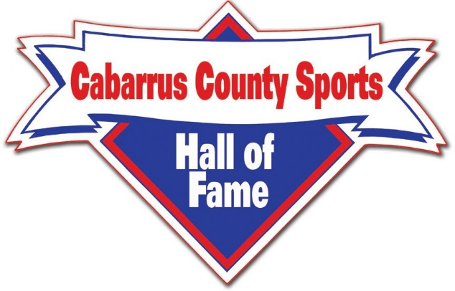

E.Z. SMITH, III – CHAIRMAN BRYAN TYSON - VICE CHAIRMAN HARRY MILLS – SECRETARY JIMMY AUTEN – TREASURER
2026 FUNDRAISING CAMPAIGN
LEVELS OF CONTRIBUTIONS: “LIFETIME” CONTRIBUTORS - $10,000.00 (10 TICKETS FOR LIFE) 7 - YEAR “LEGEND” SPONSORSHIP - $5000.00 (6) 3 - YEAR “LEGACY” SPONSORSHIP - $2500.00 (5) 1 - YEAR “CORPORATE” / INDIVIDUAL DONORS - $1000.00 (4) 1 – YEAR “ASSOCIATES” - $500.00 (2 AWARDS DINNER TICKETS) 1 – YEAR “FRIENDS” $50.00 - $100.00 - $250.00 - $300.00 - $350.00 - $400.00
PLEASE MAKE CHECKS PAYABLE TO: Cabarrus County Sports Hall of Fame. MEMO LINE: Write the LEVEL of Contribution you are Making.
Contributor’s Name / Company: ________________________________________ Address: ___________________________________________________________ City:_____________________ State: __________________ Zip Code: _________ Email: _____________________________________________________________ Business Phone: ______________Home Phone: ___________Cell: ____________
CONTRIBUTION AMOUNT: __________ TYPE OF PAYMENT ____________
MAIL THIS FORM and CHECKS TO: Cabarrus County Sports Hall of Fame P. O. Box 1374 Mt. Pleasant, NC 28124

